Epsom & Ewell F.C.
14
v
Windsor
Saturday, 3rd January 2015
Happy New Year!

For our League match this afternoon we welcome the players, officials and supporters of Windsor, along with today's match officials and of course our own regular faces.

Firstly, I apologise for the small hand-printed programme today. Due to our printers closing early for Christmas we had a choice of getting this issue printed on the 12th December or doing it ourselves. To do it this early just wasn’t cost effective as you can never predict the weather and we could have ended up on the day with six inches of snow and a bundle of wasted programmes! We will be producing a much larger programme for the visit of Farnham in two weeks, including match reports from all the recent games.

We have met today’s opponents on many occasions, yet last season was the first time we completed a league double over them. Even that was a close run thing as a 92nd minute equaliser for Windsor was answered thirty seconds later by a thumping Alex McKay header to win us a game we thought would end in a draw.

Because of these printing deadlines I was unable to recap our pre-Christmas matches and shall do so now. An early sending off for Sam Robinson gave us a mountain to climb at Badshot Lea on Saturday 13th December, although we did lead twice through Kyle Hough penalties before losing harshly 4-2.

Three days later we hosted Spelthorne Sports here and won 4-3. A goal from Matt Farrell just before half time set us up, and this was added to almost immediately after the half time break when Matt Robinson took advantage of a defensive miscommunication. Following another sending off, this time for Alex McGregor, the visitors reduced the lead only for Matt Ferdinando to find the net with a quality strike from an angle. However, Spelthorne scored twice more to level it up and with the man advantage pushed for a winner but we took all three points when Ferdinando blocked a clearance into the net from close range!

We had no game on Saturday 20th December and last Saturday’s game at Raynes Park Vale was postponed. We try again on 14th February.

Following today’s match we travel to Ashford Town next week before a trip to Molesey the following Tuesday in the last sixteen of the Surrey Senior Cup. They are solid but certainly not unbeatable so you never know. Then two weeks today we will host Farnham Town.

Thank you for following the Salts. The club, Glyn and the boys all value your support.

Rich

Cover photo this week by Gemma Jarman

Matt Ferdinando celebrates with Ali Dewar and Sam Robinson in the picture after his winning goal against Spelthorne Sports

Cherry Red Records
Combined Counties League
Premier Division Table 2014/15
Up to date | P | W | D | L | F | A | Pts | GD | H | A
Cove | 24 | 17 | 4 | 3 | 58 | 37 | 55 | +21 | 7/3 | 0-1
Ashford Town (Mx) | 23 | 17 | 2 | 4 | 58 | 24 | 53 | +34 | 2-4 | 10/1
Molesey | 21 | 16 | 0 | 5 | 62 | 19 | 48 | +43 | 1-3 | 28/2
Windsor | 23 | 15 | 3 | 5 | 56 | 27 | 48 | +29 | 3/1 | 11/4
Camberley Town | 20 | 14 | 3 | 3 | 44 | 14 | 45 | +30 | 7/2 | 0-1
Spelthorne Sports | 21 | 12 | 2 | 7 | 47 | 36 | 38 | +11 | 4-3 | 3-0
Hartley Wintney | 22 | 10 | 3 | 9 | 25 | 34 | 33 | -9 | 21/2 | 1-2
Mole Valley SCR | 24 | 9 | 5 | 10 | 46 | 54 | 32 | -8 | 1-0 | 5-2
Badshot Lea | 23 | 9 | 4 | 10 | 43 | 44 | 31 | -1 | 21/3 | 2-4
Bedfont Sports | 23 | 9 | 3 | 11 | 32 | 42 | 30 | -10 | 0-1 | 2-0
Epsom & Ewell | 22 | 9 | 2 | 11 | 41 | 37 | 29 | +4 | - | -
Colliers Wood United | 22 | 9 | 2 | 11 | 39 | 38 | 29 | +1 | 4/4 | 2-3
Farnham Town | 22 | 8 | 5 | 9 | 47 | 48 | 29 | -1 | 17/1 | 2-0
Raynes Park Vale | 22 | 7 | 4 | 11 | 30 | 40 | 25 | -10 | 0-1 | 14/2
Knaphill | 20 | 7 | 3 | 10 | 26 | 48 | 24 | -22 | 18/4 | 4-1
Chertsey Town | 22 | 7 | 2 | 13 | 32 | 50 | 23 | -18 | 1-2 | 14/3
Horley Town | 21 | 6 | 4 | 11 | 41 | 51 | 22 | -10 | 2-2 | 6/4
Westfield | 23 | 5 | 5 | 13 | 33 | 47 | 20 | -14 | 31/1 | 0-4
Frimley Green | 23 | 5 | 4 | 14 | 40 | 64 | 19 | -24 | 0-0 | 25/4
Guildford City | 22 | 5 | 2 | 15 | 37 | 64 | 17 | -27 | 4-1 | 28/3
Hanworth Villa | 21 | 3 | 4 | 14 | 26 | 45 | 13 | -19 | 3/3 | 5-2

Lucky Day? – 3rd January
Played 12 - Won 3 Drawn 1 Lost 8 - F 21 A 30 - PPG 0.83 - Awful
Club record against Windsor (incl Windsor & Eton)
Played 43 - Won 17 Drawn 11 Lost 15 - F 81 A 79 - PPG 1.40 - Average
Last visit
Tuesday 1st April 2014 - Won 2-1 - Combined Counties League

Results and Fixtures
Combined Counties League Cup Second Round – Saturday 13th December
Alton Town | 1-4 | Farnham Town
Combined Counties League – Saturday 13th December
Badshot Lea | 4-2 | Epsom & Ewell
Bedfont Sports | 3-6 | Guildford City
Camberley Town | 4-2 | Chertsey Town
Cove | 3-4 | Ashford Town (Mx)
Knaphill | 3-1 | Colliers Wood United
Mole Valley SCR | 3-2 | Hanworth Villa
Molesey | 3-0 | Horley Town
Raynes Park Vale | 0-5 | Windsor
Westfield | 7-3 | Frimley Green
Combined Counties League Cup Third Round – Tuesday 16th December
Badshot Lea | 5-0 | Guildford City
Combined Counties League – Tuesday 16th December
Epsom & Ewell | 4-3 | Spelthorne Sports
Mole Valley SCR | 2-1 | Bedfont Sports
Combined Counties League Cup Third Round – Wednesday 17th December
Colliers Wood United | 3-2 | Horley Town
Combined Counties League – Saturday 20th December
Ashford Town (Mx) | 2-1 | Raynes Park Vale
Chertsey Town | 0-1 | Hartley Wintney
Colliers Wood United | 1-2 | Cove
Frimley Green | 4-5 | Horley Town
Hanworth Villa | 1-1 | Westfield
Windsor | 0-3 | Molesey
Combined Counties League – Saturday 27th December
Ashford Town (Mx) | 3-1 | Spelthorne Sports
Camberley Town | 4-0 | Frimley Green
Cove | 2-6 | Farnham Town
Hanworth Villa | 1-1 | Bedfont Sports
Hartley Wintney | 0-3 | Badshot Lea
Windsor | 2-0 | Guildford City
Combined Counties League – Saturday 3rd January
Badshot Lea | V | Hanworth Villa
Camberley Town | V | Knaphill
Chertsey Town | V | Guildford City
Colliers Wood United | V | Hartley Wintney
Cove | V | Frimley Green
Epsom & Ewell | v | Windsor
Farnham Town | V | Ashford Town (Mx)
Raynes Park Vale | V | Molesey
Spelthorne Sports | V | Horley Town
Westfield | V | Bedfont Sports

Windsor F.C. – History
Summer 2011 and it’s rather ironic that 100 years of senior football at Stag Meadow should be celebrated by the birth of a brand new club, Windsor FC, which came to be following the sad demise after 118 years of Windsor & Eton FC. During the final death throes of the previous club it became apparent, following several well attended supporters’ meetings, that the will was there to continue to host a senior football club in Windsor for the community to embrace and, therefore, on February 4th 2011 WFC Football Community Development Ltd was registered with Companies House with the aim of achieving that objective. Founding Director Kevin Stott and a newly-appointed management committee then set about the long and sometimes arduous task of turning that dream into a reality.

A business plan centred around self-sustainability was formulated and presented to the Football Association which eventually led to acceptance for the new club at level 5 of the non-league system and an allocation to compete in the Premier Division of the Cherry Red Records Combined Counties League for season 2011/12. Now the new club had been accepted it needed a name and invitations were extended to the people of Windsor to nominate and then vote on the new naming process and thus Windsor FC was born.

Self-sustaining and community are the two key elements behind the ethos of the new setup and the provision of a 3rd generation artificial surface training area/small-sided games pitches at the Great Park end of the ground, when completed, will form the first brick in the foundations of the self-sustainability module as well as providing a much-needed facility for the community to use. The other main development thus far on the community side is welcoming on board the 34 teams and over 300 players of New Windsor Youth FC who will now be known as Windsor FC Youth, adopting the club badge and colours and providing a progression pathway from small-sided through to senior football.

Our founding season turned out to be a very exciting one, eventually finishing as runners-up to worthy Champions Guildford City in the league and we also made it to the semi-finals of the Berks & Bucks Senior Trophy.

Several weeks into season 2012/13 a major decision to operate without a budget was taken to free up funds for the regeneration plans at the ground and the management team and all but three of the playing squad left immediately. Mick Woodham was appointed as our new manager and had two days to get together a squad before our next league game. Despite some heavy defeats early in his tenure as he built a squad of local youngsters the club never lost faith and Mick eventually put together a squad that was to finish a very creditable 6th in the league.

Recognition from the league away from football itself was achieved with a runners-up award for the programme in the Premier Division and FA Groundsman of the Year award for the CCL and this was added to in August 2013 when our groundsman Lewis Clements won the FA Groundsman of the Year Award for the whole of Step 5 and 6 football nationally, something both he and the club are justifiably proud of whilst also giving some extra publicity to the CCL.

This building process will continue for season 2013/2014 as players are added to the squad with the emphasis on young local players interspersed with some older experienced heads but whatever happens results wise we’ll continue to enjoy visiting the many friends we made in our first two seasons in the Combined Counties League and hope they all enjoy their visits to Stag Meadow.

Centre page for results

Centre page for results

Match and Ball Sponsorships – 2014/15
Opponent | Date | Match Sponsor | Ball Sponsor
Raynes Park Vale | 05/08/14 | Club President - Stella Lamont
Horley Town | 25/08/14 | EEFC Management Committee
Croydon (FAC) | 30/08/14 | EEFC Media Officer - Richard Lambert
Frimley Green | 13/09/14 | Dave Gaffney and friends
Guildford City | 30/09/14 | The Jarman family
Mole Valley SCR | 07/10/14 | Mark and Carmel Murphy
Bedfont Sports | 11/10/14 | Epsom & Ewell F.C. Colts
Knaphill (LC) | 14/10/14 | Geoff and Steve Dyke
Ashford Town (Mx) | 18/10/14 | The Building Shop, Bookham
Chertsey Town | 28/10/14 | In Memory of Bob Bexley
Molesey | 22/11/14 | The Cabling Crew 0208 -224 4110
Camberley Town (SSC) | 02/12/14 | In memory of Liz and Doug Burns
Spelthorne Sports | 16/12/14 | Paul Merritt - long serving supporter
Windsor | 03/01/15 | Ezara Beddoe
Farnham Town | 17/01/15
Westfield | 31/01/15
Camberley Town | 07/02/15
Hartley Wintney | 21/02/15
Hanworth Villa | 03/03/15
Cove | 07/03/15
Badshot Lea | 21/03/15
Colliers Wood United | 04/04/15
Knaphill | 18/04/15
For League, League Cup and Surrey Senior Cup Matches:

Match sponsorship - £40.00 Match ball sponsorship - £25.00.
Combined Offer of Match and Match Ball sponsorship for £55.00.

For F.A. Cup and F.A. Vase matches:

Match sponsorship - £50.00 Match ball sponsorship - £30.00.
Combined Offer of Match and Match Ball sponsorship for £65.00.
----------------------------------------------------------------------------------------------------------------------------
Sponsorship includes

Admission, programmes, advertising (if required) and hospitality.

If you are interested, just speak to a Committee Member, you know where we are!
Alternatively, drop me an email at: richard.c.lambert@gmail.com

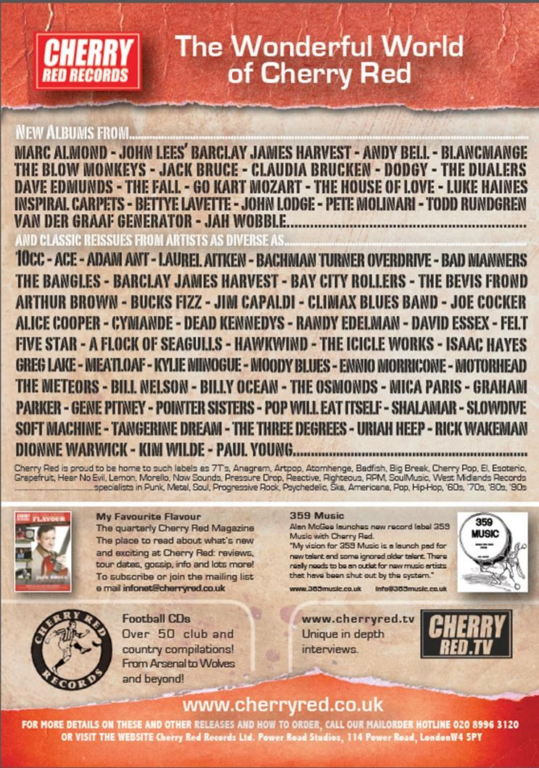
Salts Super Six Predictor

The Salts Super Six Predictor is live again and the new deadline is 3rd January. Tickets will be on sale at the Windsor home game.

The competition is easy to play and you don’t even have to be at the match! To win, you simply need to predict the results of six matches correctly from the three options, fill in the form and make sure it is back with one of our distributors before the deadline on the ticket. The latest fixtures are shown here. This week we delve into the F.A. Cup with six intriguing ties to predict.

If you are a club regular, you just need to place your name on the sheet, although if you aren’t, then we’ll need a contact number from you too. We will announce any winners on the website within three working days, so don’t worry, we won’t miss you!

The prize pot is currently £120 but will continue to go up, if unclaimed, by the cost of 50% of all the sold tickets. In other words, if we sell 100 tickets at £2 before the deadline, and the pot isn’t won, then the next prize will be £220! You’ll always know the size of the pot before you enter.

Please note that if there is more than one winner, the prize pot would be shared between the winners. All you need to do now is have a go, as many times as you like!

Good luck!

Combined Counties League – Premier Division
Saturday, 3rd January 2015 - Kick-off 3.00 p.m.
Epsom and Ewell  (Royal Blue & White hoops) | V |  | Windsor F.C.  (All Red)
 | NUMBERS
Michael Eacott |  |  | Carl Dennison
James Taylor |  |  | Kyle Jeffrey
Matt Tanton |  |  | Jamie Di Guiseppe
© Anthony Panayi |  |  | Jeff Brown
George Murphy |  |  | Chris Ellis
Dan Dean |  |  | Adam Kirby ©
Alex McKay |  |  | Aaron Minhas
Matt Farrell |  |  | James Quinn
Kyle Hough |  |  | Jason Sheehan
Ali Dewar |  |  | Omar Riaz
Matt Robinson |  |  | Kyle Lucas
Taylor Smith |  |  | Lewis Leonetti
Sam Robinson |  |  | Travis Richardson-Hodge
Matt Ferdinando |  |  | Barry Dunbar
Luke Gaffney |  |  | George Gould
Steve Rowe |  |  | Eddie Lazarczuk
Sam Currie |  |  | Dan Molloy
Alex McGregor |  |  | Robert Lazarczuk
Daryl Cooper-Smith |  |  | Justin Courtnage
Savva Panayiotou |  |  | Dan Hicks
Glyn Mandeville | MANAGER |  | Mick Woodham
Matt Smith | ASSISTANT |  | Tony Thompson
Steve Eacott / Alex McKay | COACHES |  | Tony Thompson
Ken Jones | PHYSIO |  | Amy Tulley
REFEREE: D.O’Shea (Aldershot)
ASSISTANTS: D.Holmwood (Horley), M.Ford (Sutton)
Today’s Match and Match Ball are sponsored
by Ezara Beddoe

OUR NEXT VISITORS TO HIGH ROAD
Farnham Town
Saturday 17th January 2015 - Kick-off 3.00 p.m.
Combined Counties League – Premier Division

